HIGH QUALITY CODE COURSE
TEAMWORK ASSIGNMENT

TEAM BULLS-AND-COWS-2

JULY 2014

Team Members:
•Ивайло Христов /Ivaylo1987/
•Ивайло Папазов /HellFiend/
•Стефан Владков /S.Vladkov/
•Гергана Дамянова /g_damyanova/
•Стефан Петров /Steff/

Inactive Members:
•Стефан Миревски /elfoles/
•Любомир Ангелов /lubomir.angelov/

Github repository of the project:
https://github.com/TeamBullsAndCows2/HQC-Team-Project---Bulls-and-Cows

REFACTORING DOCUMENTATION for the “BULLS and COWS” GAME

- Initial structure: 2. Final structure:

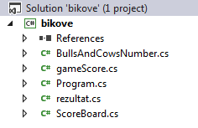
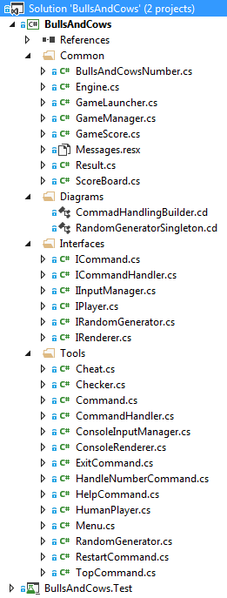

We made an overall redesign of the project structure:

- We renamed all initial files and folders as appropriate.
- We split the logic of the game as shown on the pictures above.
- the initial classes are kept, renamed as appropriate and refactored according to the “single responsibility” principle;
- the rest of the game logic is exported to additional classes we created with the SOLID and DRY principles in mind;
- there are 4 design patterns implemented in the game: 2 structural (Bridge, Façade), 2 behavioral(Mediator, Command), 1 creational (Singleton);
3. Unit tests added.

More detailed information:

- We introduced 6 new interfaces, which level up the abstraction: ICommand, ICommandHandler, IInputManager, IPlayer, IRandomGenerator, IRenderer.

- A folder of “tools” is created, containing additional classes that take part in the command handling and execution by the GameManager.

- A GameManager class is created, serving as a “mediator” between the GameEngine and the other classes taking part in the gameplay.

- An Engine class is created, serving as a “facade” for the GameManager.

- The Engine is run by the GameLauncher method (We like having a Main method ☺ ).

- The BullsAndCowsNumber keeps its initial name, but its functions are limited to the handling of the generated number and the output from the “help” command.

- The GameScore class deals with the players’ scores and their rating.

- The Result class returns the number of bulls and cows to the player. The Checker class in “Tools” makes the check.

- The ScoreBoard class displays the scoreboard in the game – scores made by player. It uses an external file to write and read the records.

The code is formatted according to the conventions for C#:

- Removed all unneeded empty lines;
- Inserted empty lines between methods;
- Split the lines containing several statements into several lines;
- Formatted the curly braces { and } according to the best practices for the C# language;
- Put { and } after all conditionals and loops (when missing);
- Character casing: variables and fields made camelCase; types and methods made PascalCase;
- Using statements have a proper order;
- Formatted all other elements of the source code according to the best practices introduced in the course “High-Quality Programming Code”;
- All variables named in a self-documenting way;
- Introduced constants;
- Inserted comments when needed;
- Added XML documentation to all classes.

Additional remarks:

• We strived to redesign the game in a way that will carry further extentions without a problem.
• There are a lot of StyleCop warnings left, most of which are caused by missing documentation on fields and properties. We decided to keep the code cleaner and more readable, and make documentation only for the most important pieces of the project. It’s pointless to write above a property “This is the property of the class.”, because it’s obvious.

